Smart Farmer - IoT Enabled Smart Farming

APPLICATION SOLUTION ARCHITECTURE

|  |  |
| --- | --- |
| Team ID | PNT2022TMID20067 |
| Project Name | Smart Farmer - IoT Enabled Smart Farming Application |

Solution Architecture Diagram:

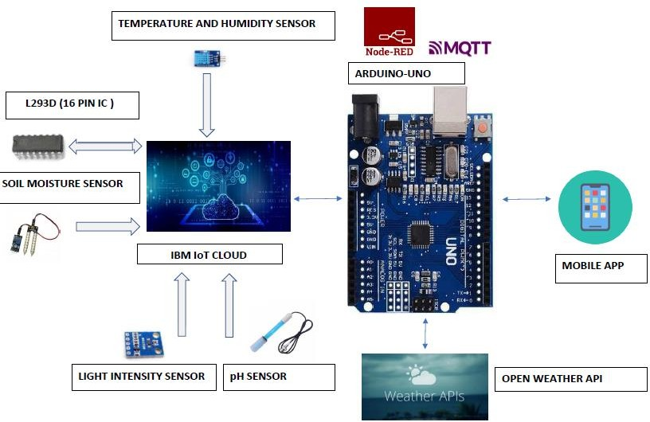

* The different soil parameters (temperature, humidity, light intensity, pH level) are sensed using different sensors and the obtained value is stored in IBM cloud.
* The L293D is a 16-pin Motor Driver IC which can control a set of two DC motors simultaneously in any direction. The L293D is designed to provide bidirectional drive currents of up to 600 mA (per channel) at voltages from 4.5 V to 36 V (at pin 8!).
* Arduino UNO is used as a processing unit which processes the data obtained from sensors and weather data from weather API.
* Node-RED is a programming tool for wiring together hardware devices, APIs and online services in new and interesting ways. It provides a browser-based editor.
* The MQTT protocol is followed for communication.
* All the collected data are provided to the user through a mobile application which was developed using MIT app inventor.
* Open Weather provides hyperlocal minute forecast, historical data, current state and from short-term to annual and forecasted weather data. All data is available via industry standard APIs.
* The user could make decision through an app, whether to water the crop or not, depending upon the sensor values.